H.T No
Regulations:
A17

Sreenidhi Institute of Science and Technology
(An Autonomous Institution)
Code No: 6A242 Date: 26-Nov-2020 (FN)

B.Tech I-Year II-Semester External Examination, Nov/Dec - 2020 (Supplementary)
NETWORK ANALYSIS (ECE and ECM)

Time: 2 Hours Max.Marks:75

Note: a) No additional answer sheets will be provided.
b) All sub-parts of a question must be answered at one place only, otherwise it will not be valued.
c) Missing data can be assumed suitably.

ANSWER ANY 5 OUT OF 8 QUESTIONS. EACH QUESTION CARRIES 15 MARKS.

1. | a) | Find I and V_{ab} in the circuit shown below.  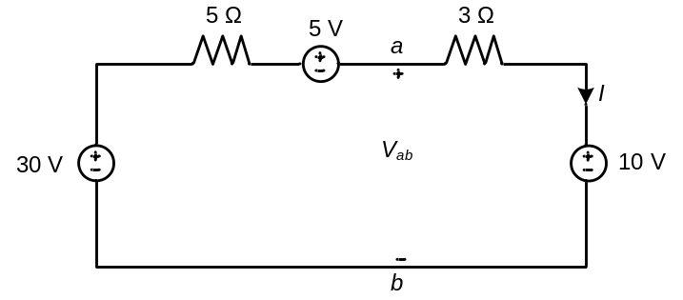 | [8M]
 | b) | Find nodal voltages at 1 and 2 for the circuit shown below.  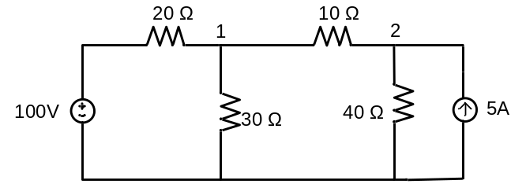 | [7M]
2. | a) | A parallel RLC circuit has R=5kΩ , L=8mH and C=60mF. Determine:  i) the resonant frequency ii) the bandwidth iii) the quality factor | [8M]
 | b) | A series-connected circuit has R=4Ω, L=25mH, Calculate the value of C that will produce a quality factor of 50. Calculate ω_{1,} ω₂ and Bandwidth. Determine the average power dissipated at ω=ω₀ , ω₁ and ω_{2.} Take V_{m}=100V. | [7M]
3. | a) | Explain dot convention with a neat diagram. | [8M]
 | b) | Two coils are mutually coupled, with L₁ = 50 mH, L₂=120 mH, k=0.5. Calculate the maximum possible equivalent inductance if  i) the two coils are connected in series ii) the coils are connected in parallel. | [7M]
4. | a) | State Thevenin’s theorem and explain with a neat circuit diagram. | [8M]
 | b) | Use source transformation to find V_{o} in the below figure.  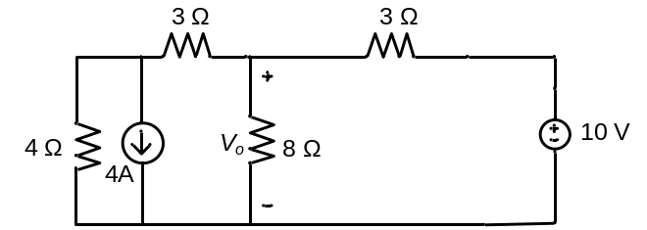 | [7M]
5. | a) | Express the ABCD-parameters of a Two port network in terms of Z-parameters. | [8M]
 | b) | Determine the h-parameters for the circuit shown in below figure  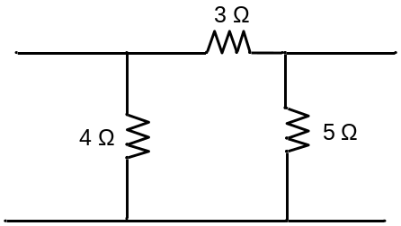 | [7M]
6. | a) | A series R-C circuit with R = 10Ω and C = 2F has a sinusoidal voltage source 200 sin (500t +θ ) applied at time when θ = 0 . Find the expression for current. | [8M]
 | b) | Find the complete solution for the current in a series R-L-C circuit when excited by a sinusoidal voltage source. | [7M]
7. | a) | Obtain the equivalent resistance at the terminals a-b for the circuit shown.  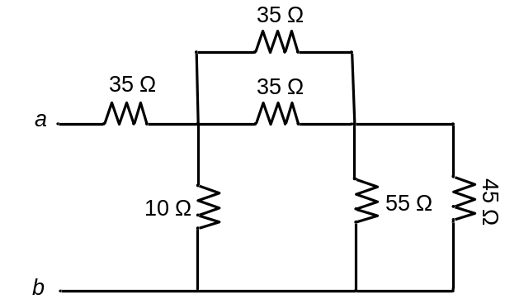 | [8M]
 | b) | Derive the expression for form factor and peak factor of a sinusoidal waveform. | [7M]
8. | a) | State and explain Millman’s theorem. | [8M]
 | b) | Explain Self and Mutual inductance with the help of a neat diagram. | [7M]

-- 00 -- 00 –

